**INTI International College Penang School of Computing**

**3+0 Bachelor of Science (Hons) in Computer Science, in collaboration with Coventry University, UK**

# Coursework cover sheet

**Section A - To be completed by the student.**

|  |  |
| --- | --- |
| Full Name: SHARON TAN | |
| CU Student ID Number: 14007547 | |
| Semester: 2 | |
| Session:  **April 2023** | |
| Lecturer:  **Puteri Nursyawati Azzuri (puteri.azzuri@newinti.edu.my)** | |
| Module Code and Title:  **4067CEM Software Design** | |
| Assignment No. / Title:  **Continuous Assessment** | % of Module Mark:  **50** |
| Hand out Date:  **12 May 2023** | Due Date:  **Task 1: 04 June 2023, by 11.59pm.**  **Task 2: 07 July 2023, by 11.59pm**  **Task 3: 07 July 2023, by 11.59pm.**  **Task 4: 07 July 2023, by 11.59pm.**  **Task 5: 07 July 2023, by 11.59pm.** |
| Penalties: No late work will be accepted. If you are unable to submit coursework on time due  to extenuating circumstances, you may be eligible for an extension. Please consult the lecturer. | |
| Declaration: I/we the undersigned confirm that I/we have read and agree to abide by the University regulations on plagiarism and cheating and Faculty coursework policies and procedures. I/we confirm that this piece of work is my/our own. I/we consent to the appropriate storage of our work for plagiarism checking.  Signature(s): | |

# Section B - To be completed by the module leader

|  |  |  |
| --- | --- | --- |
| Intended learning outcomes assessed by this work:   1. Understand and apply appropriate concepts, tools, and techniques to each stage of the software development. 2. Understand and apply design patterns to software components in developing new software. 3. Demonstrate an understanding of project planning and working to agreed deadlines, along with professional, interpersonal skills and effective communication required for software production.   5. Demonstrate an awareness of, and ability to apply, social, professional, legal, and ethical standards as documented in relevant laws and professional codes of conduct such as that of  the Malaysian National Computer Confederation. | | |
| Marking scheme | Max | Mark |
| 1. User Story Mapping | 20 |  |
| 2. Setting up a GitHub |  |
| Repository | 10 |
| 3. Creating a Class diagram and |  |
| design pattern selection | 30 |
| 4. Creating a Prototype User |  |
| Interface and Usability Testing | 20 |
| 5. Discuss the ethical issue |  |
| related to the software | 20 |
| Total | 100 |  |

**Table of Contents**

|  |  |  |
| --- | --- | --- |
| No. | Title | Page |
| 1. | Introduction | 1 |
| 2. | Task 1 – User Story Mapping | 2 - 7 |
| 3. | Task 2 – Setting up a GitHub Repository | 8 |
| 4. | Task 3 – Creating a Class diagram and design pattern selection | 9-12 |
| 5. | Task 4 – Creating a Prototype User Interface and Usability Testing | 13 |
| 6. | Task 5 – Discuss the ethical issue related to the software | 14 |
| 7. | Conclusion | 15 |
| 8. | References | 16 |

**Introduction**

This assessment is focused on designing a Student Business System for College. The term ‘business’ comes with different definitions. Based on Cambridge Dictionary, business means the commercial activities carried out by someone to earn profits by providing goods and services. On the other hand, it can also be defined as things or activities to do that are related to someone (Business, 2023). In further research, it is found that the term ‘Student Business System’ is used by Australian National University and Swinburne University of Technology as a system providing administration and academic services for their students (Student Business Systems, Swinburne University of Technology, 2023; Student Business Systems, Australian National University, 2023).

There are 5 tasks to be completed as for the design process. The assessment begins with the feedback collection from at least 10 real users for the features and functionalities of the system. Information collected is then interpreted to generate a user story mapping. A class diagram is then designed with the clarification of each class’s responsibilities. Based on that, a Unified Modelling Language (UML) diagram is created with a suitable design pattern for solving a specific problem. Now the process comes to the task of prototyping and followed by list out questions for usability testing. After all of the above tasks are done, an analysis needs to be carried out critically about the ethical issues of the system. Lastly, a GitHub repository is created to organize all the works and make sure not exceeding the due date.

Overall, this assessment is planned to create comprehensive designs for the Student Business System for College mainly based on the preferences of real users, the college students. For example, user story mapping, UML diagram as the class diagram and the prototype. The purpose of this system is to enhance the effectiveness of a college institution as well as improve student experiences.

**Task 1 – User Story Mapping**

**1.0 Data collection**

Google Forms is used in this assessment to collect the feedback of real users toward the Student Business System for College. The link is sent through conversations and extra information is given when the respondents meet any problems or questions when answering the survey forms. As a result, there are 15 responses with at least 10 different features hoped by them as a user. The survey form is closed after obtaining all the required information.

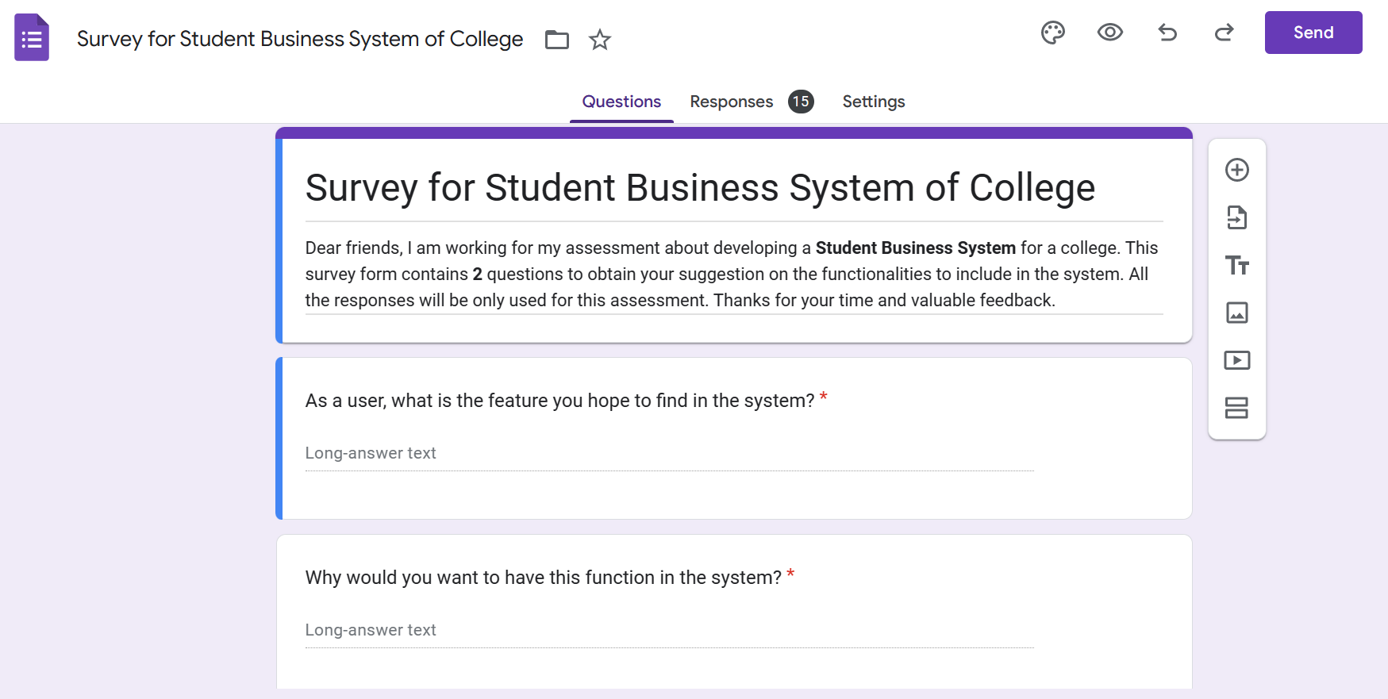

Figure 1.0: The figure shows the title, description and questions of the survey form.

**1.1 Data categorization**

As there are some similar responses in the survey forms for the features in question 1, hence Trello is used for better organization and categorization. The answers of question 1 are used as the list’s title and respective answers in question 2 are recorded in the card.

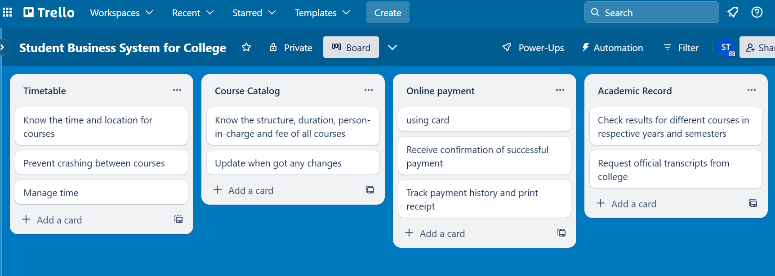

Figure 1.1: The figure shows the categorization of responses from survey form.

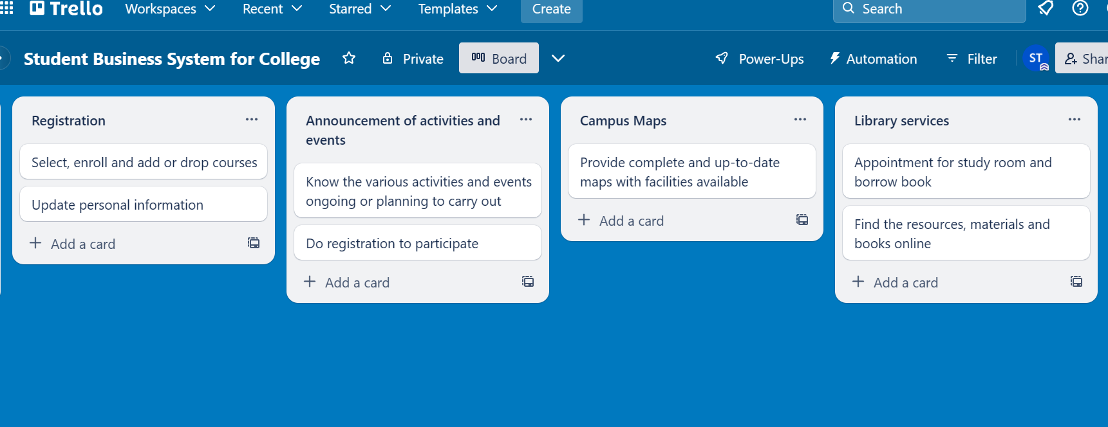

Figure 1.2: The figure shows the categorization of responses from survey form.

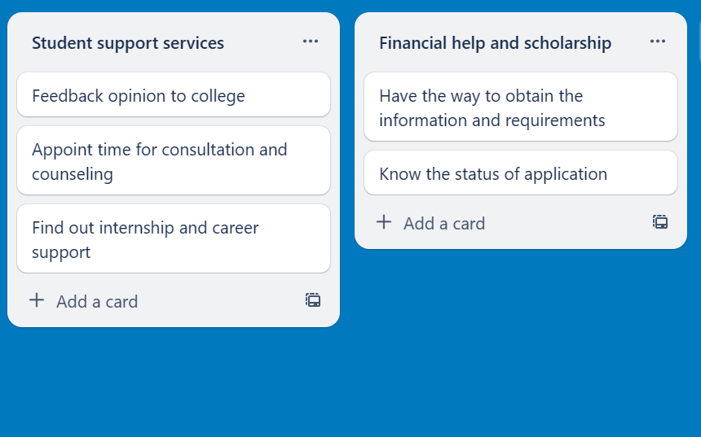

Figure 1.3: The figure shows the categorization of responses from survey form.

**1.2 User stories and backlog**

Based on what has been done in Trello, 10 user stories and respective backlog are generated with small modifications for fluency. Basically, the different features in the title are used as the activities to be performed by users and the reasons for having these features in the card are the goals aimed to achieve.

User Stories

1. As a user, I want to look for my timetable so that I can know the time and location for courses, prevent crashing between courses and better time management.

2. As a user, I want to find out the course catalog so that I can know the structure, duration, person-in-charge and fee of all courses. Update is needed when there are any changes.

3. As a user, I want to pay the fees online by using cards so that I can easily track payment history and print receipts. I hope to receive confirmation after a successful payment.

4. As a user, I want to check my academic record so that I can access my results for different courses in specific years and semesters and also request official transcripts from college.

5. As a user, I want to do my registration so that I have the ability to select the courses to enroll, add or drop. I also hope that I can update my personal information.

6. As a user, I want to receive the announcements of activities and events so that I can participate by quickly registering for the various activities and events that are ongoing or planned to be carried out by college.

7. As a user, I want to access complete and up-to-date online campus maps so that I get familiar with campus faster. The maps should include all the facilities available as well.

8. As a user, I want to access library services online so that I can quickly find the resources, materials and books in the library. I hope there is also an appointment feature for a study room and borrowing book.

9. As a user, I want to easily access student support services so that I can provide feedback to college, schedule consultations or counseling sessions and also find information about internships and career opportunities.

10. As a user, I want to find out information about financial aids and scholarships so that I can obtain requirements for application and track the status of application.

Backlog

Goals:

1. Know the time and location for courses, prevent crashing between courses and better time management.

2. Know the structure, duration, person-in-charge and fee of all courses with updates when there are any changes.

3. Easily track payment history, print receipt and receive confirmation after a successful payment.

4. Access results for different courses in specific years and semesters and also request official transcripts from college.

5. Have ability to select the courses to enroll, add or drop and update personal information.

6. Participate by quickly registering for the various activities and events that are ongoing or planning to carry out by college.

7. Get familiar with campus faster with the maps including all the facilities available.

8. Quickly find the resources, materials and books in the library besides appointment for study room and borrowing book.

9. Provide feedback to college, schedule consultations or counseling sessions and also find information about internships and career opportunities.

10. Obtain requirements for application and track the status of application.

Activities:

1. Look for a timetable.

2. Find out the course catalog.

3. Pay fees online by using cards.

4. Check academic record.

5. Do registration.

6. Receive announcements of activities and events.

7. Access complete and up-to-date online campus maps.

8. Access library services online.

9. Easily access student support services.

10. Find out information about financial aids and scholarships.

Tasks:

1. Timetable page – Select year and semester

2. Catalog page – Select a course from the list

3. Payment page – Pay for selected courses

4. Academic page – Select year and semester

5. Log In – Personal information – Enrollment page – Select courses

6. Activities and Events page – Click on an activity or event

7. Maps page – Click on different blocks or floors

8. Library page

9. Student support services page

10. Financial Aids and Scholarships page – Select a financial aids or scholarship program

**1.3 User story mapping**

For the next step, Figma is utilized to create the user story mapping to provide a complete overview of the system. It included sections of person, goals, activities, tasks and releases. Each of the sections is represented using distinct colours of sticky notes. The arrangement of sticky notes is important to clarify the relationship between each other.

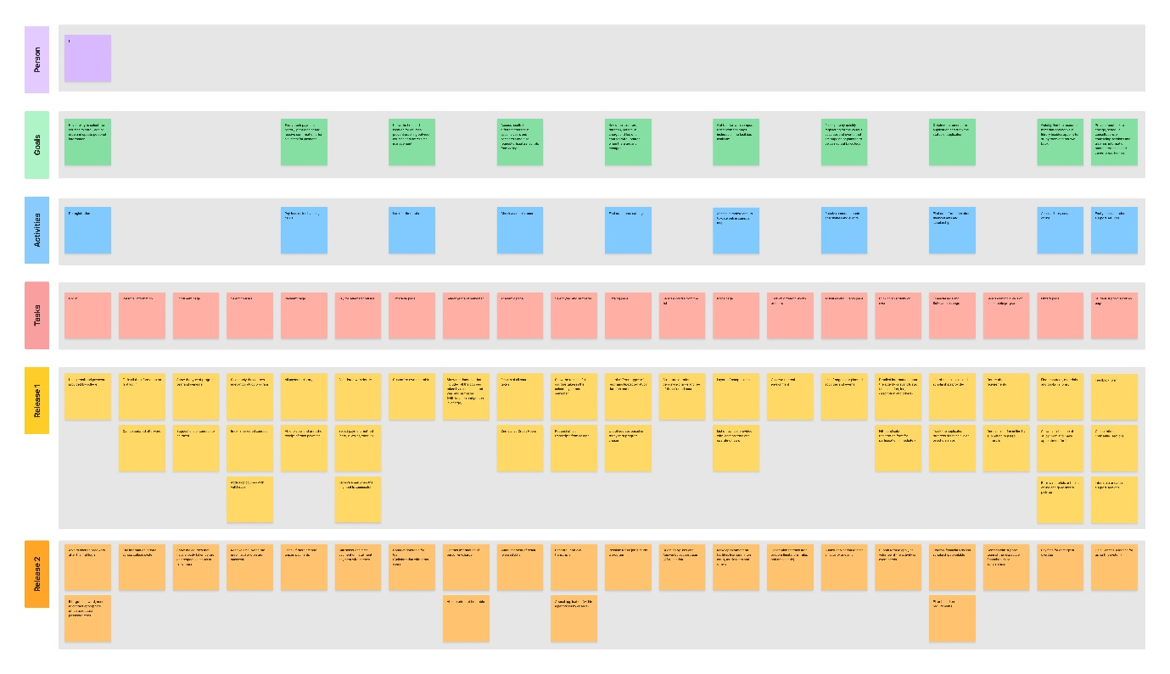

Figure 1.4: The figure shows the overall view of user story mapping for the system.

Link for user story mapping: <https://www.figma.com/file/dtc90gPX9GJrDijUBtsA6x/Student-Business-System-for-College?type=whiteboard&node-id=0%3A1&t=nEPkMrroz4vzxCXg-1>

**Task 2 – Setting up a GitHub Repository**

GitHub link: <https://github.com/xsharonxx/SharonTan_P22014778_4067CEM.git>

**Task 3 – Creating a Class diagram and design pattern selection**

**3.0 Class diagram**

A class diagram is created based on the user story mapping above using Draw.io. The main purpose is to visualize the structures of the Student Business System for College. By having the classes blocks, relationships, roles and multiplicities, it enhances developers’ understanding and facilitates development process.

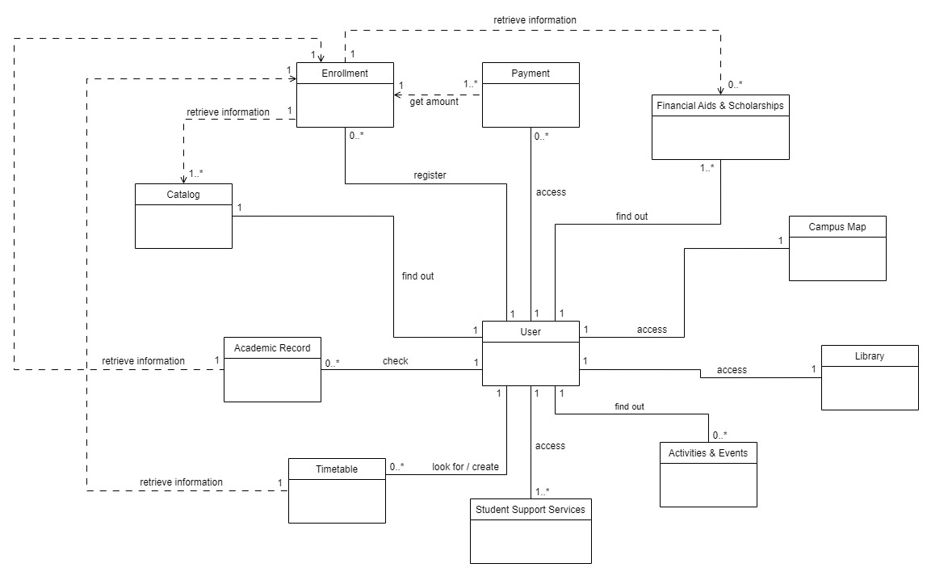

Figure 3.0: The figure shows the class diagram created for the system.

**3.1 Responsibilities of classes**

User

Responsible for storing personal information of users such as name, age, email, password, address, school and program taken. It acts as a basic foundation for user authentication. Only the person having the user account is able to have access to the system.

Enrollment

Enables users to carry out registration for a new semester. It manages and verifies the processes of enrolling in, adding and dropping courses. The class retrieves information from Catalog class to obtain details and fees of all the selected courses. It will also retrieve information from the Financial Aids & Scholarships class to determine whether the user has any approved aids or scholarships to be applied.

Payment

Manages transaction information for each payment. It stores histories and details of all payments such as status, date, payer, payee and amount. The total amount to be paid depends on the fees calculated in Enrollment class. It enables users to pay off once or in batches. Payment of fines are also handled by this class.

Timetable

Stores information of timetables, including auto-generated timetables which are based on the enrolled courses retrieved from Enrollment class and also timetables created by users themselves. It allows users to organize and personalize the timetables according to their own planning and preferences.

Academic Record

Responsible for storing all relevant information about the user’s academic progress such as results, courses taken and cumulative credit hours. It retrieves enrolled courses from Enrollment class as well for updating respective records. Additionally, it facilitates the processes of requesting official transcripts and appealing.

Catalog

Stores the information of all the programs and courses available in the college. For example, structure, duration, fee, lecturer and requirement. It provides real-time communication between users and responsible personnel for solving confusions.

Campus Map

Stores information about the college campus, from buildings, floors to rooms. It included the operating hours, booking options and rules and regulations of each facility within the campus.

Activities & Events

Responsible for managing information such as date, time, venue and organizer about various activities and events to be carried out. It will send out announcements to encourage users to register for joining those activities and events.

Financial Aids & Scholarships

Manages information of financial aids and scholarships offered by the college or external organizations. It facilitates the communication and interaction between users and providers by handling the submission and processing of application forms.

Library

Manages resources and books in the college library to facilitate the functions of searching, borrowing and returning. Besides, it also manages reservations for study rooms and the borrowing of books.

Student Support Services

Manages information and appointments of support services provided to users. For example, counseling or consultation, internship or career and feedback. It ensures all the users receive support upon their requests correctly.

**3.2 Design pattern**

One of the problems considered for this system is the dependencies around the enrollment process which involves multiple aspects such as catalog management, course enrollment, timetable creation, academic record management, financial aid and scholarship handling and payment processing. If there are any changes in a class, the related classes should be updated as well to ensure the accuracy and fluency of the system operation.

A behavioral pattern is selected to address the communications between classes to overcome the problem above. Among the behavioral patterns, the observer design pattern is chosen due to its suitability in handling the system’s requirements. It consists of subject and observer objects that are interrelated. When changes occur in a subject, the observer is able to notify the changes and update automatically for the related subjects. Therefore, it is suitable for the enrollment process of the system.

For example, if the course details in catalog have modifications, the observer of enrollment class will notify and can update the related information for the course enrollment. Same for the financial aid and scholarship, if a user is unable to achieve requirements of applying financial aid or scholarship and being removed, the course enrollment will be updated when the observer of enrollment class notifies it. The enrollment observer will also be responsible for sending out email for users when they enroll in, add or drop the courses in enrollment class. For payment, academic record and timetable classes, they will have their own observers to notify the changes of course enrollment and have updates on their own classes. Payment class looks for total amount to pay while academic record and timetable classes look for courses to record courses taken and create semester timetables.

**3.3 UML diagram**

An UML diagram is generated to represent the observer design pattern selected for the problem above. Observer is an abstract class with four concrete observer classes. Classes of enrollment, payment, timetable and academic record having their own observer classes for getting notified upon changes of related information and updating the data in the classes. All of the classes are with attributes and operations for better clarification about their respective properties and behavior.

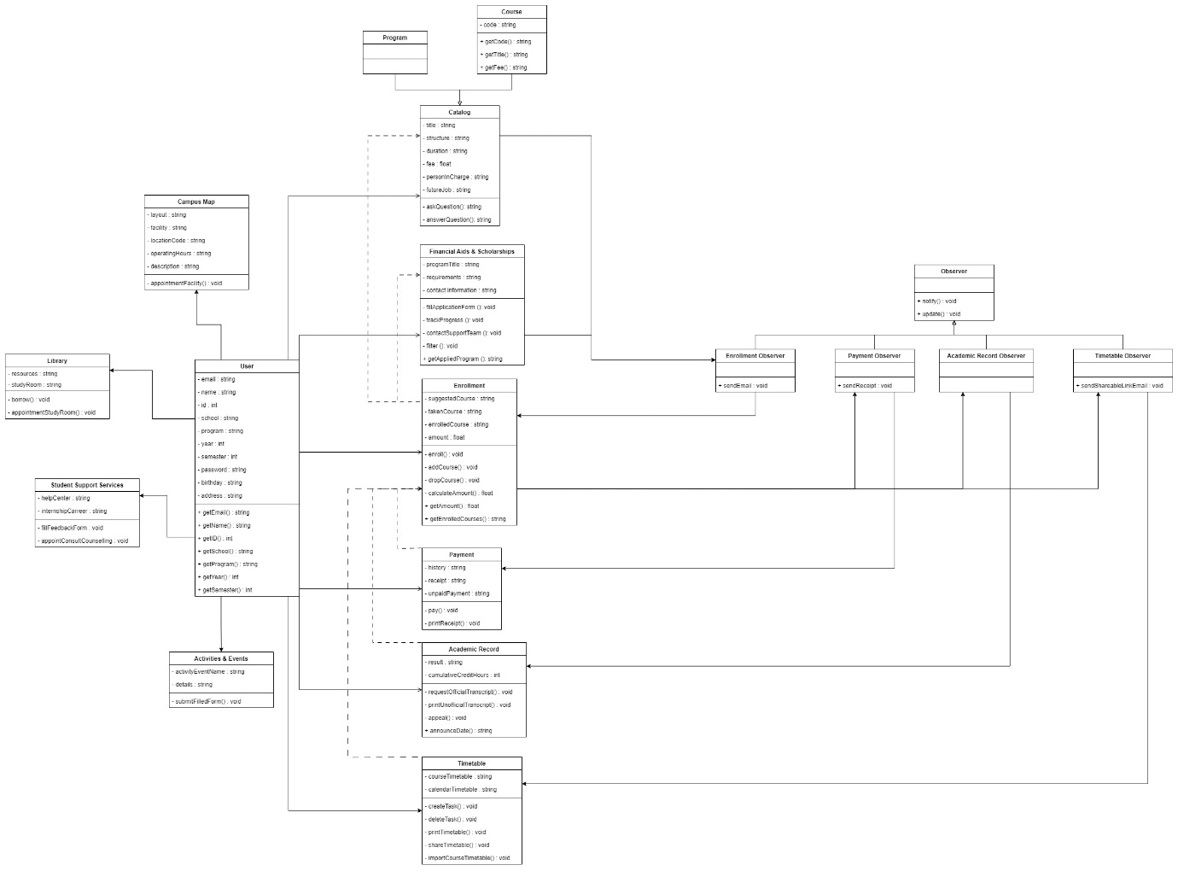

Figure 3.1: The figure shows the UML diagram created for the system.

Link for class diagram and UML diagram: <https://www.figma.com/file/oQA5umRBmfrpTVgAWqRdIu/class-diagram-student-business-system?type=design&node-id=0%3A1&mode=design&t=9NhF4sqGrPbA175P-1>

**Task 4 – Creating a Prototype User Interface and Usability Testing**

**Task 5 – Discuss the ethical issue related to the software**

**Conclusion**

**References**

*Business*. (2023). Cambridge Dictionary. Available at: <https://dictionary.cambridge.org/dictionary/english/business> (Accessed: 20 May, 2023)

*Student Business Systems*. (2023). Swinburne University of Technology. Available at: <https://www.swinburne.edu.my/student-engagement/student-business-systems> (Accessed: 20 May, 2023)

*Student Business Systems*. (2023). Australian National University. Available at: <https://services.anu.edu.au/business-units/division-of-student-administration/student-business-systems> (Accessed: 20 May, 2023)